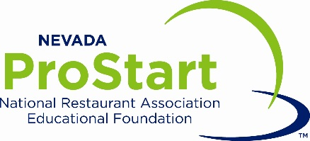

Art Institute of Henderson Henderson, NV
February 2, 2018

Logistics and Cost Estimates
The Nevada ProStart Invitational will be held at the Art Institute in Henderson, Nevada. The following information is provided for planning and budgeting purposes only.
Hotel Room Rates
We suggest Fiesta Henderson or Sunset Station, both under $90 per night in February, and less than 15 minutes drive.
Transportation
Airport:
McCarran International Airport (LAS) is located just 6.9 miles from the Art Institute.
Ground Transportation:
- Let us know if you need assistance booking a shuttle.
Parking
- Parking is free in both recommended hotels and at the Art Institute.
Questions?
- The information above is provided at this time to assist in planning and budgeting for the Nevada ProStart Invitational. Contact Sophie Ayache for questions (sayache@nvrestaurants.com).

