Competition Tableware Requests

Tableware requests must be submitted to NvRAEF by Monday, January 8, 2018

Please email your dish requirements.

Email: sayache@nvrestaurants.com

The following pages provide descriptions of the tableware available at the competition. In the left-hand ‘Quantity’ column on the form, indicate the total number of pieces you will need to present each course. Remember, you will need one plate for the starter, a second for center plate, and a third plate for the dessert. And a full second set for display. All plates look like the one photographed, in various sizes.

School Name

Educator Name

Team Name (if multiple teams competing)

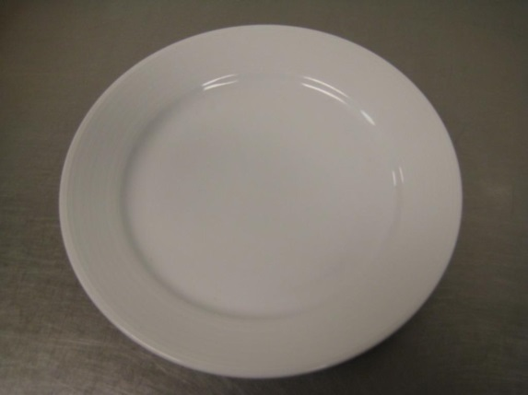

Quantity | Plate Size
 | 12 inches Round White Plate
 | 10 inches Round Plate
 | 8 inches
 | 6 inches

*sizes may vary

